Exercise : MERN Deployment Setup

Deploying to Vercel

Introduction
- Vercel is a platform for deploying the fastest React sites. You can deploy your site with zero configuration to the best frontend infrastructure.
- Develop: Build React sites that connect to your favorite APIs, databases, and content management systems.
- Preview: Integrate with any GitHub, GitLab, or Bitbucket repository for instant continuous deployment.
- Ship: Deploy your site to every edge node worldwide for the fastest React sites. Static files, Serverless and Edge Functions, and more.
- Monitor: Measure Core Web Vitals from actual devices your visitors are using with Vercel Analytics for Next.js or Gatsby.

Built-in CI/CD for React sites
Vercel has integrations for GitHub, GitLab, and Bitbucket to enable CI/CD for your React site with zero configuration. Then, you can run automated tests for performance and reliability on every push. Pull and merge requests are deployed instantly to a unique URL, accessible to your entire team.

Add your custom domain
After deploying, your new React site will automatically be assigned a .vercel.app suffixed domain. You can then add a Custom Domain on your choice, either from a third-party or purchased through Vercel.

Creating a Vercel account
Go to the Vercel website and click on the "Sign Up" button.
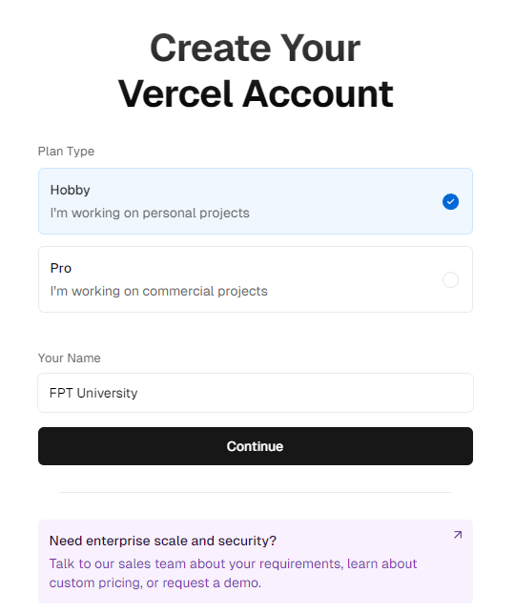
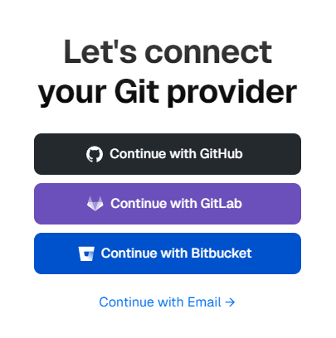
Choose account with GitHub/GitLab or Bitbucket
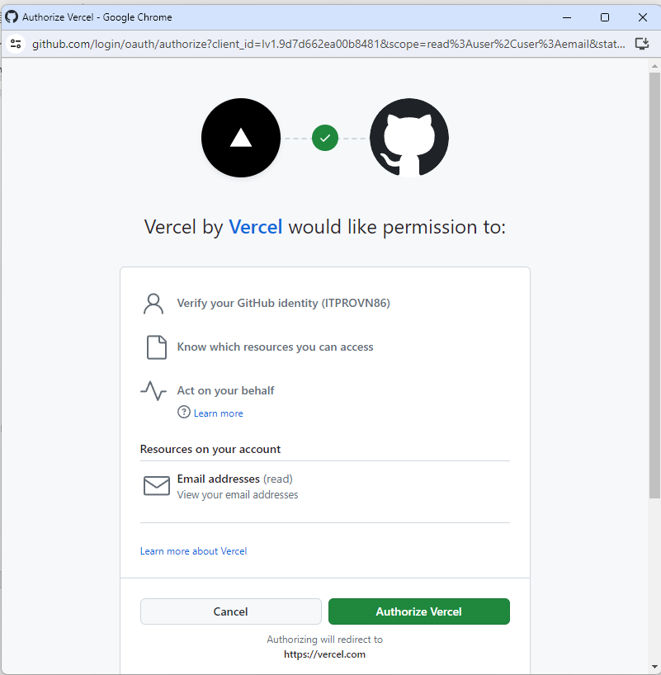
Follow the prompts to verify your email address and complete your account setup.
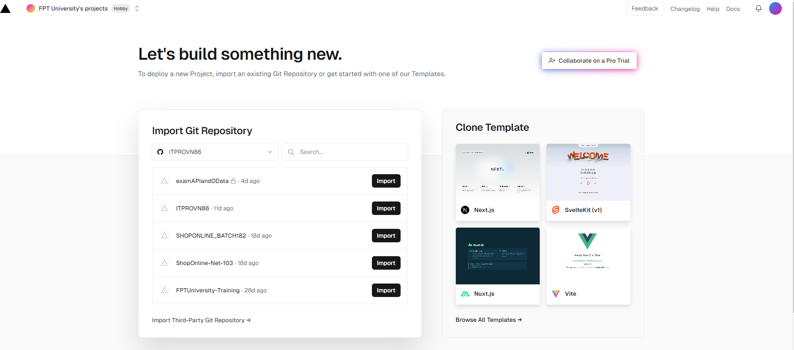

Deploy React to Vercel
- Step 1: Log in to Vercel
  - Go to Vercel Dashboard.
  - Log in to your account. If you don’t have an account, sign up first.
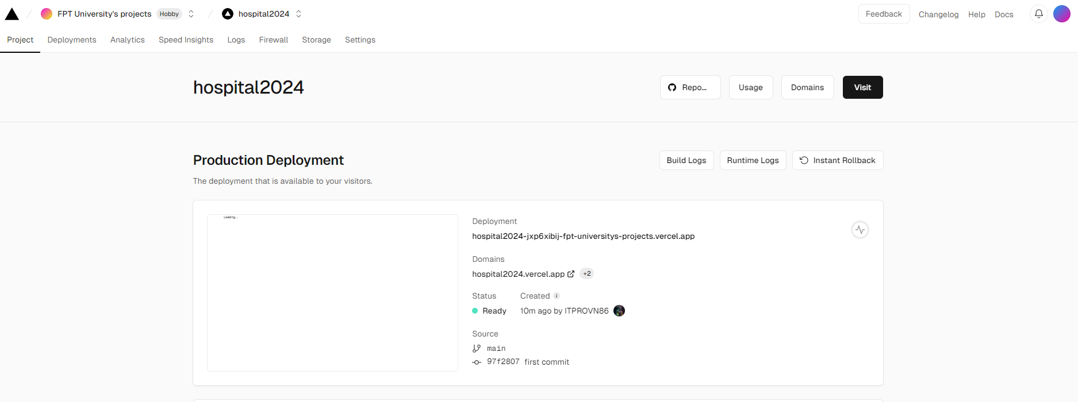
- Step 2: Create a New Project
  - On the Vercel Dashboard, click on the New Project button.
- Step 3: Import Git Repository
  - You will be presented with options to import a Git repository from GitHub, GitLab, or Bitbucket. Choose the provider where your React project is hosted.
  - If you are importing from GitHub, for instance, click on the GitHub button.
  - You may need to authorize Vercel to access your GitHub account if you haven’t already. Click on Authorize Vercel.
- Step 4: Select Repository
  - After authorizing, you will see a list of repositories from your Git account. Find the repository that contains your React project and click on Import.
- Step 5: Configure Project Settings
  - You will be prompted to configure your project settings:
  - Project Name: Set a name for your project (Vercel will suggest one based on your repository name).
  - Root Directory: If your React project is not in the root of your repository, set the path to the project directory.
  - Framework Preset: Choose Create React App if you used create-react-app, or select the appropriate preset if you used another tool.
  - Build Command: npm run build
  - Output Directory: build
Here's how it might look:
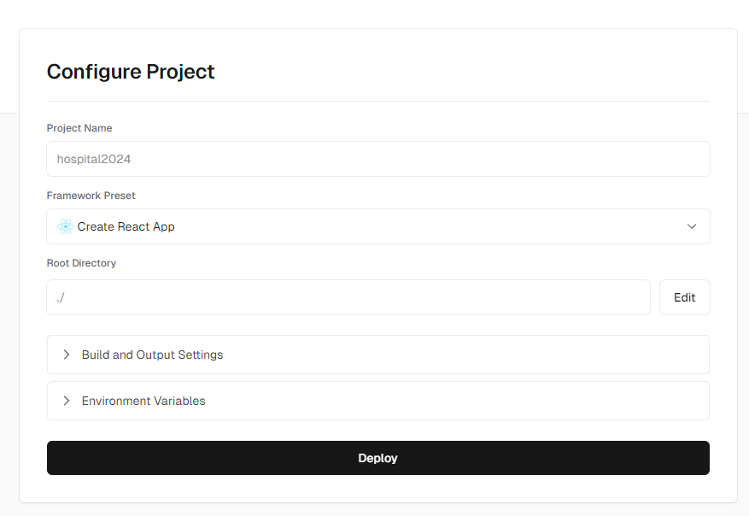
  - Click on Deploy.
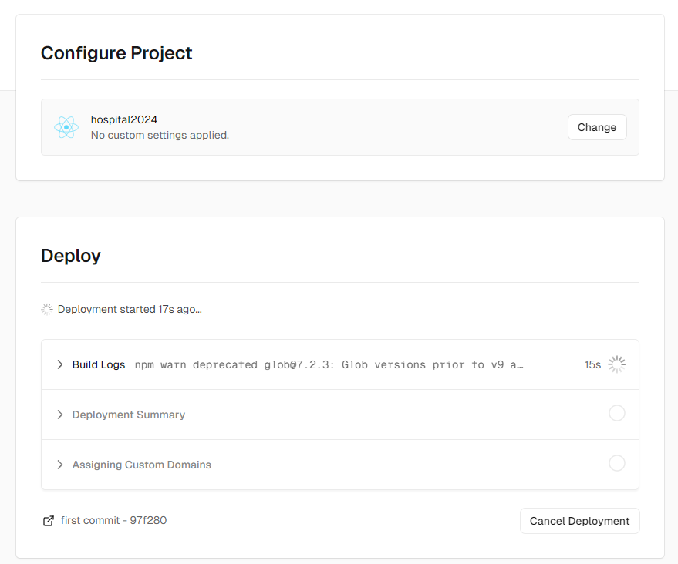
- Step 6: Deployment
  - Vercel will start the deployment process. You can see the deployment logs in real-time.
  - Once the deployment is complete, you will get a URL where your React application is live.
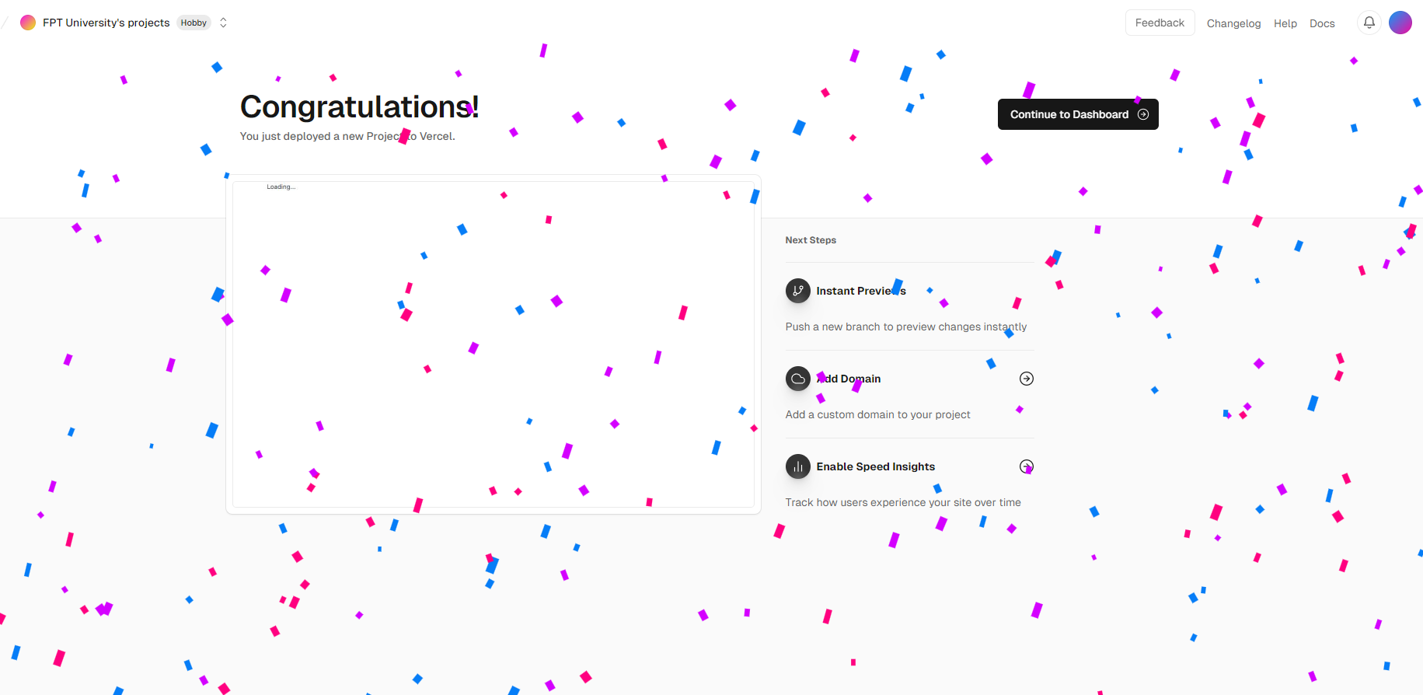
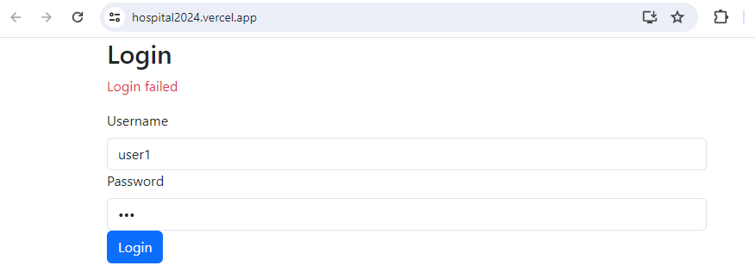
- Step 7: Continuous Deployment
  - Vercel sets up continuous deployment by default. Any future commits pushed to the linked Git repository will trigger an automatic rebuild and redeployment of your application.
Additional Tips
- Environment Variables: If your React application requires environment variables, set them in the Vercel dashboard under the Settings > Environment Variables section.
- Custom Domains: If you have a custom domain, you can link it in the Vercel dashboard under the Domains section.

MongoDB Setup
MongoDB is the database that you work with on the cloud. It is also known as MongoDB Atlas. This is easier to work with than setting up on a local machine. Go to www.mongodb.com and log in or create a new account.

Creating a New Project
After logging in. Click the New Project button.
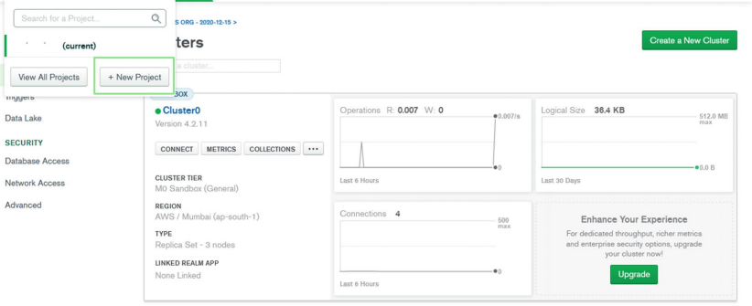
Name your project dating-app-mern, and then click the Next button
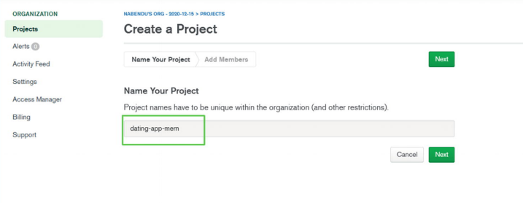
On the next screen, click the Create Project button
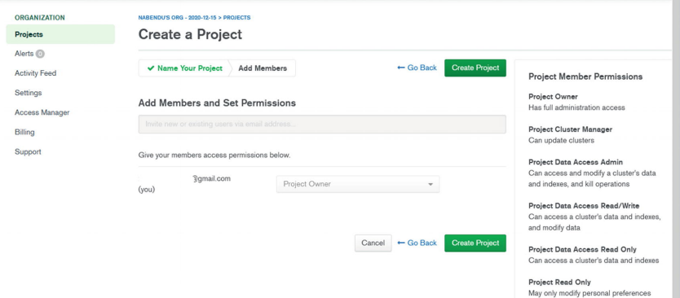
On the next screen, click the Build a Cluster button
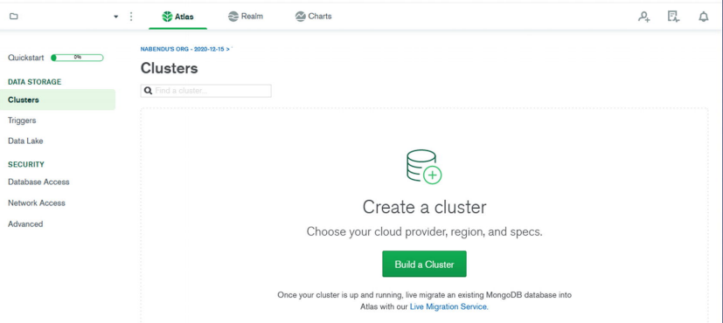
On the next screen, select the Free tier
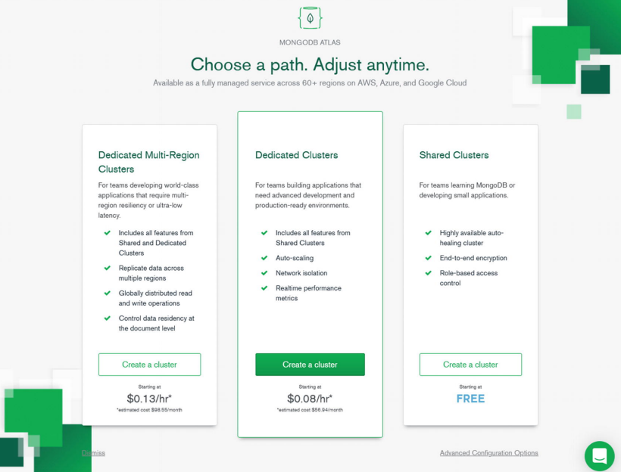
On the next screen, you need to choose the AWS region in which to create the database. (I chose Singapore because I live in VietNam, and this gives me low latency.) Afterward, click the Create Cluster button
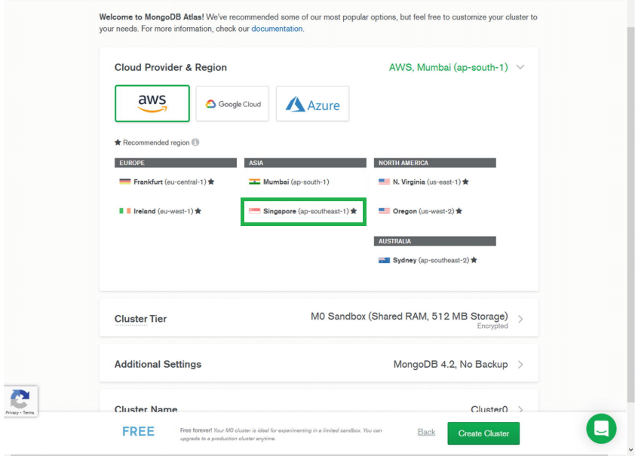
The next screen shows that the cluster has been created, which takes time. You can go back and create your.
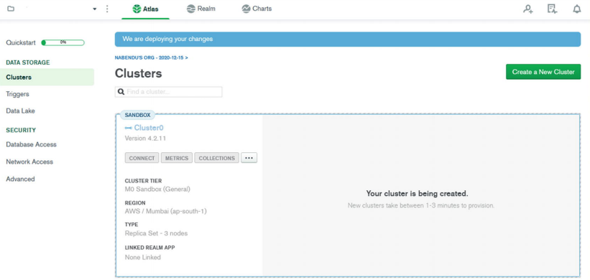

Database User and Network Access
To create a user in MongoDB, click the Database Access tab and then the Add New Database User button
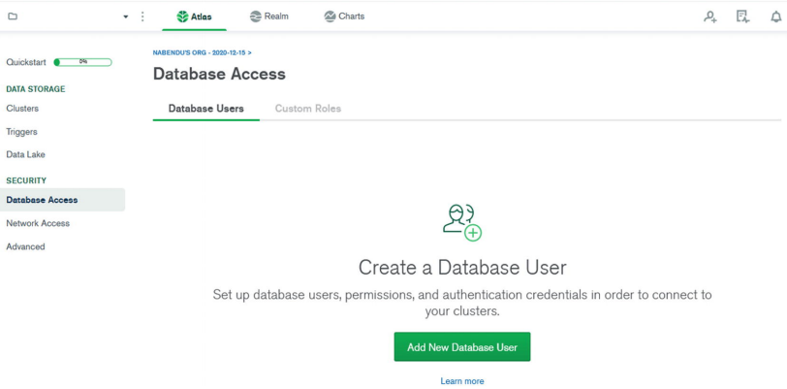
On the next screen, you need to enter a username and a password. You must remember both. Next, scroll down and click the Add User button.
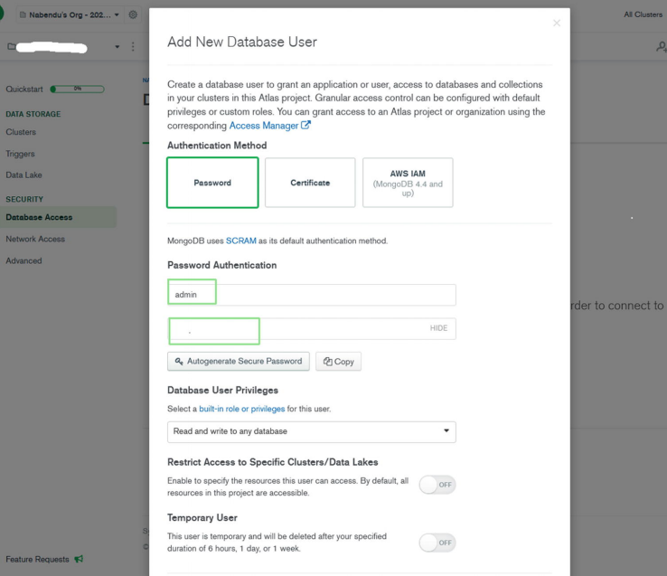
Next, go to the Network Access tab and click the Add IP Address button
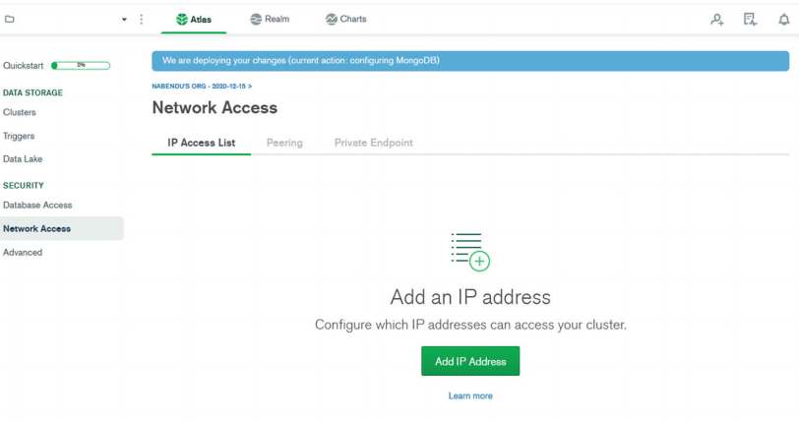
In the popup window, click the ALLOW ACCESS FROM ANYWHERE button and then click the Confirm button
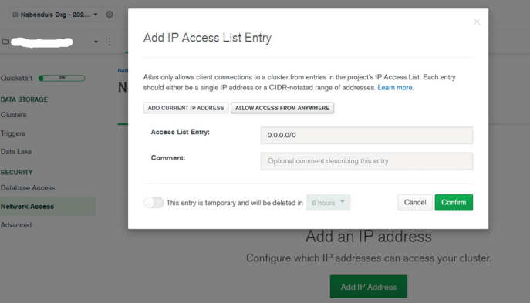
Next, return to the Cluster tab and click the CONNECT button, which opens the popup window. Click the Connect your application tab
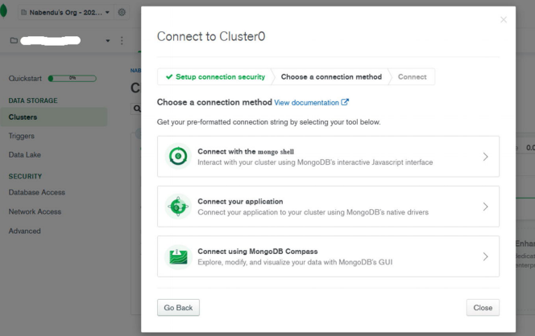
Copy the connection URL by clicking the Copy button
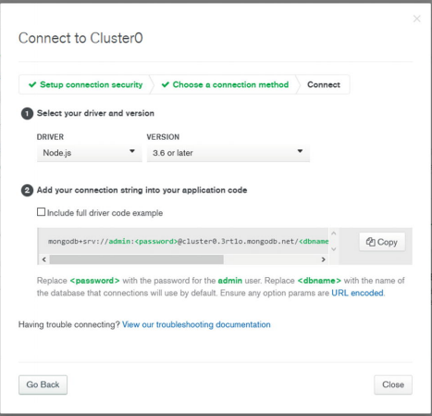

Deploying the Back End to Render

Introduction
For years, Heroku has been an excellent platform to host your Full Stack applications. But that may change, as Heroku is bringing its generous free tier to an end.
You may have received email from Heroku informing you that, starting November 28, 2022, you will not be able to host any app for free on the platform, and that you will now need to purchase paid plan.
We'll learn how to deploy your Node.js application with Express server on Render. It's a free alternative to Heroku with a similar easy deployment process.

Create a Render account
You already have this GitHub repository that you will be deploying to Render. This GitHub repository code just displays the list of top repositories and the numbers of stars for each repository in JSON format.
Go to Render.com and sign up for an account if you don’t already have one.
Render provides various ways to sign up as shown below:
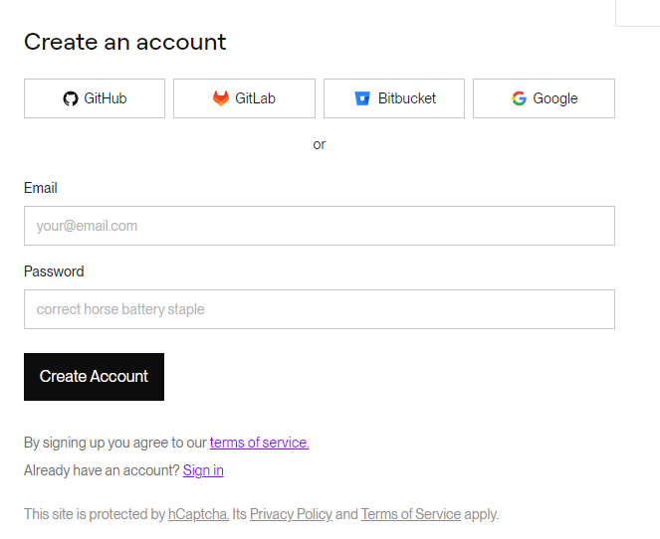

Link Your GitHub Repository
After logging in, navigate to the Render dashboard.
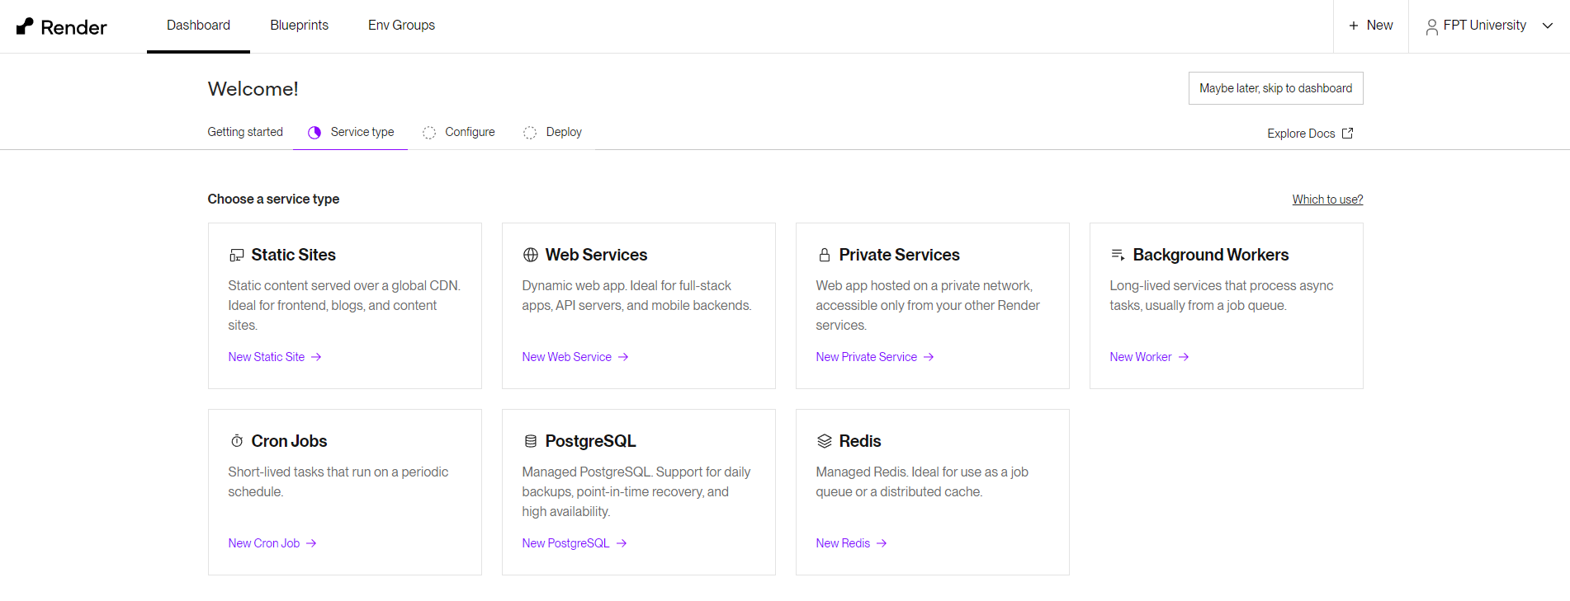
Click on the New button and select Web Service.
You will be prompted to connect your GitHub account. Authorize Render to access your repositories.

Create a New Web Service
After linking your GitHub account, you will see a list of your repositories. Select the repository that contains your NodeJS project.
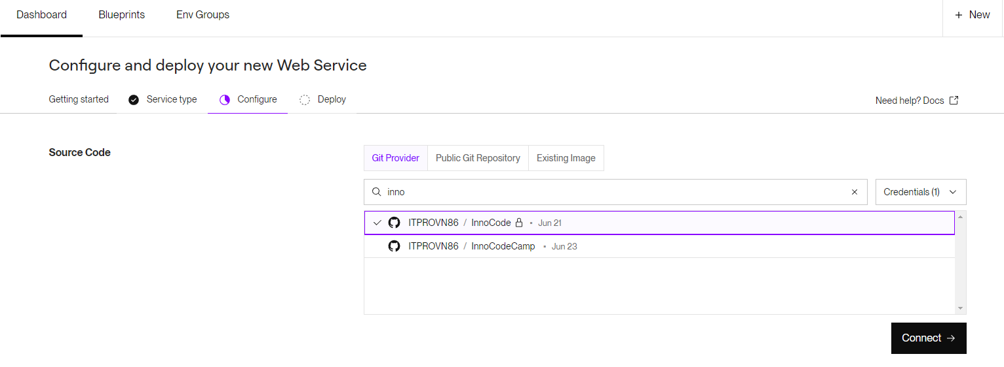
Configure your web service settings:
- Name: Choose a name for your service.
- Branch: Select the branch you want to deploy (usually main or master).
- Build Command: Set the build command to npm install
- Start Command: Set the start command to npm start (you might need to add serve as a dependency by running node server.js).
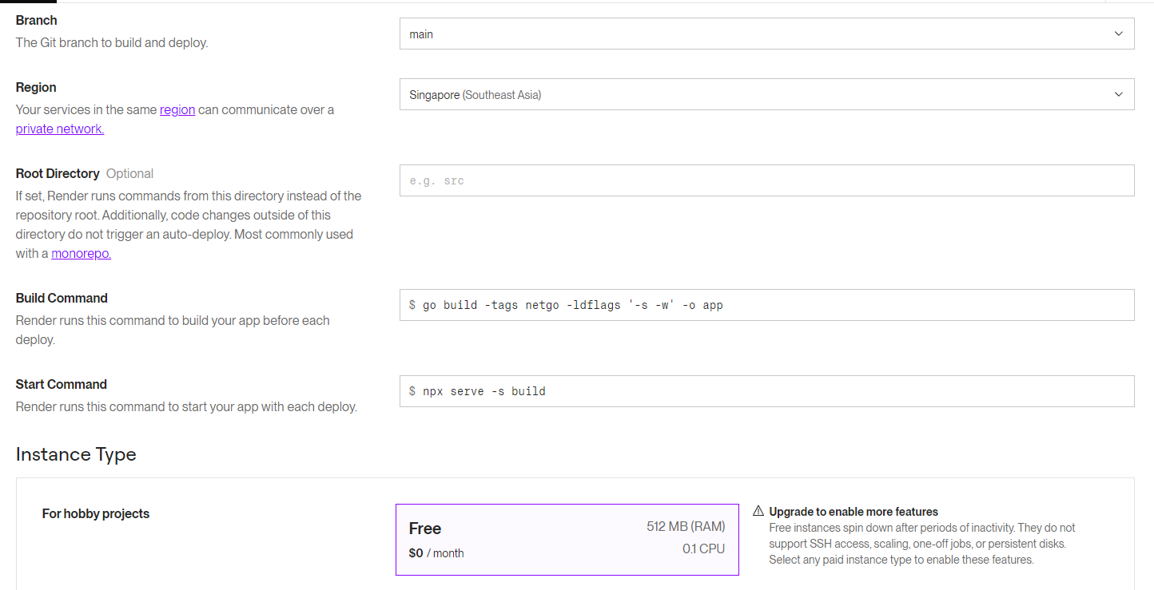

Deploy Your Application
Click Create Web Service. Render will start the deployment process.
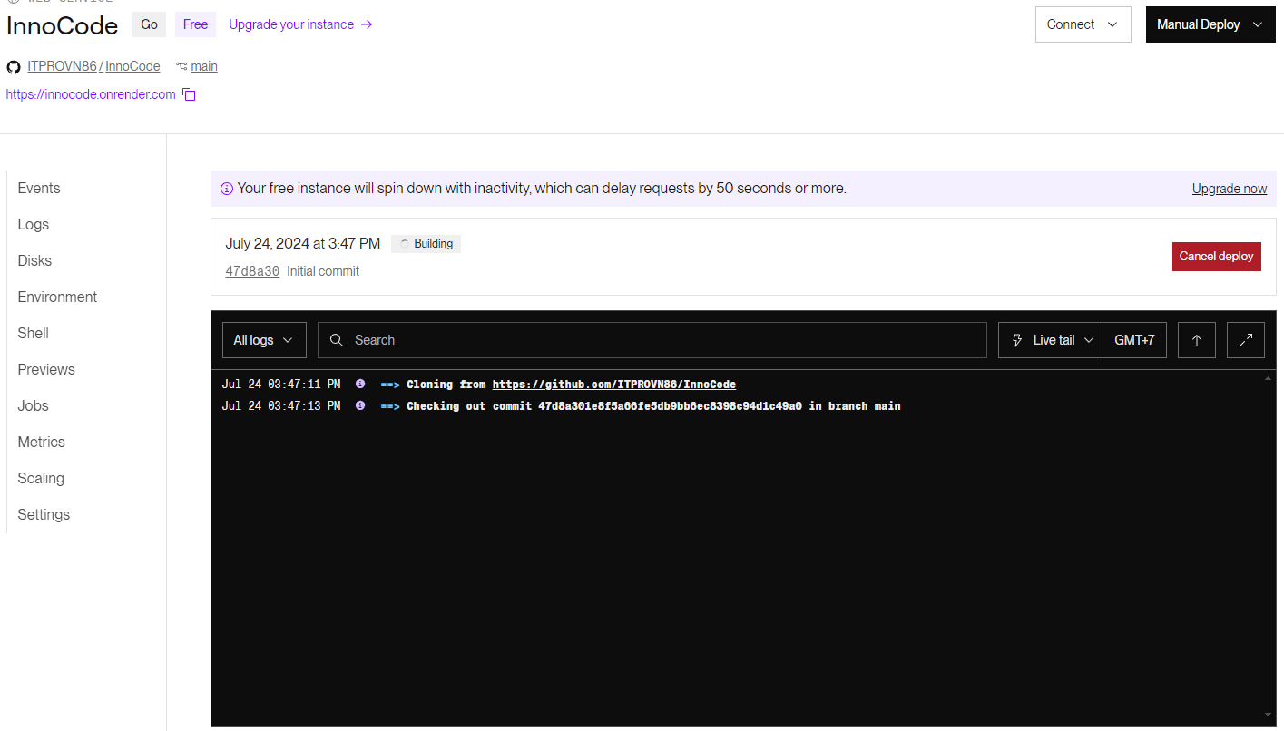
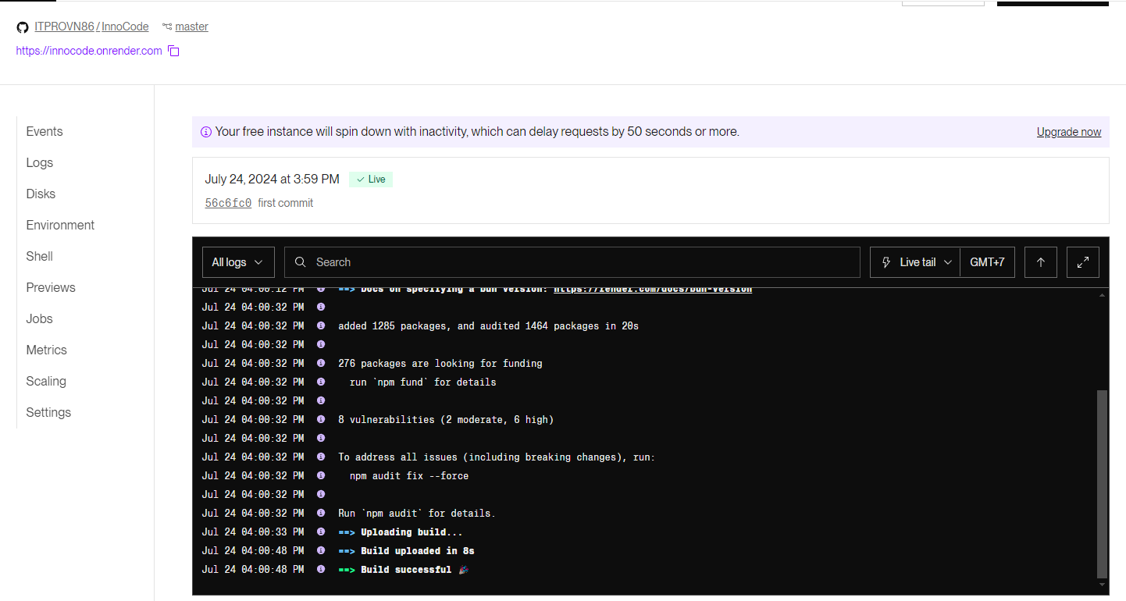
You can monitor the deployment logs in real-time on the Render dashboard.
